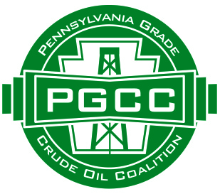

Conventional and Unconventional Oil and Gas:
Two different Industries
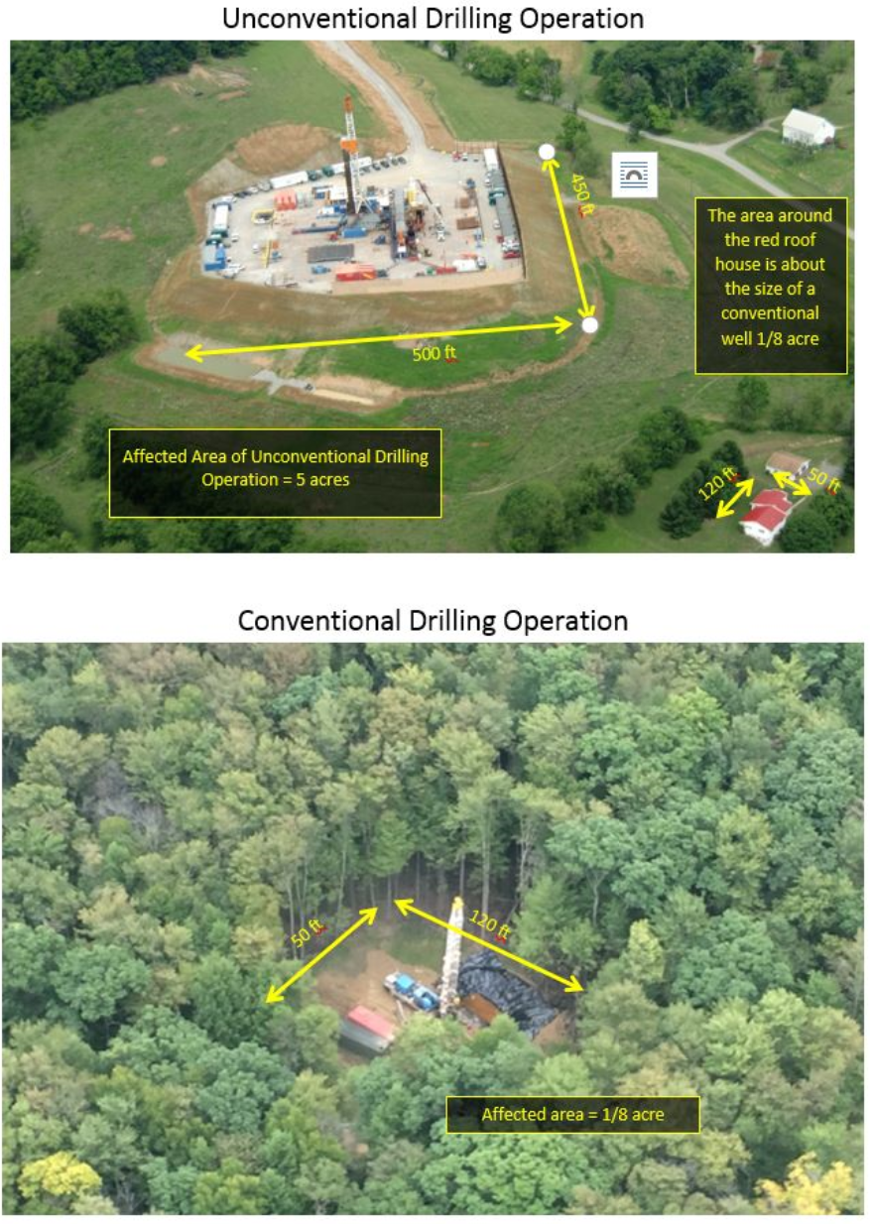

This White Paper examines the differences between Pennsylvania’s conventional and unconventional oil and gas industries. Our 160-year old conventional industry began with “Colonel” William Drake’s Titusville well in 1859. “PA Grade” oil from our conventional industry powered our nation through WW I and lubricated the bomber and fighter engines of WW II. Natural gas from our conventional wells supplies local distribution systems, and is consumed in Pennsylvania’s schools, hospitals and homes.
Conventional oil and gas is found in shallow formations throughout western PA. There are over 100,000 conventional wells operating in PA; nearly all are owned by small family businesses—many of today’s operators are third, fourth, and even fifth generation owners. We conventional operators are members of our communities. We care deeply about the quality of our environment and we live, recreate, and raise our children in the same fields where we work.
Conventional pumpjack (nodding donkey) in suburban yard

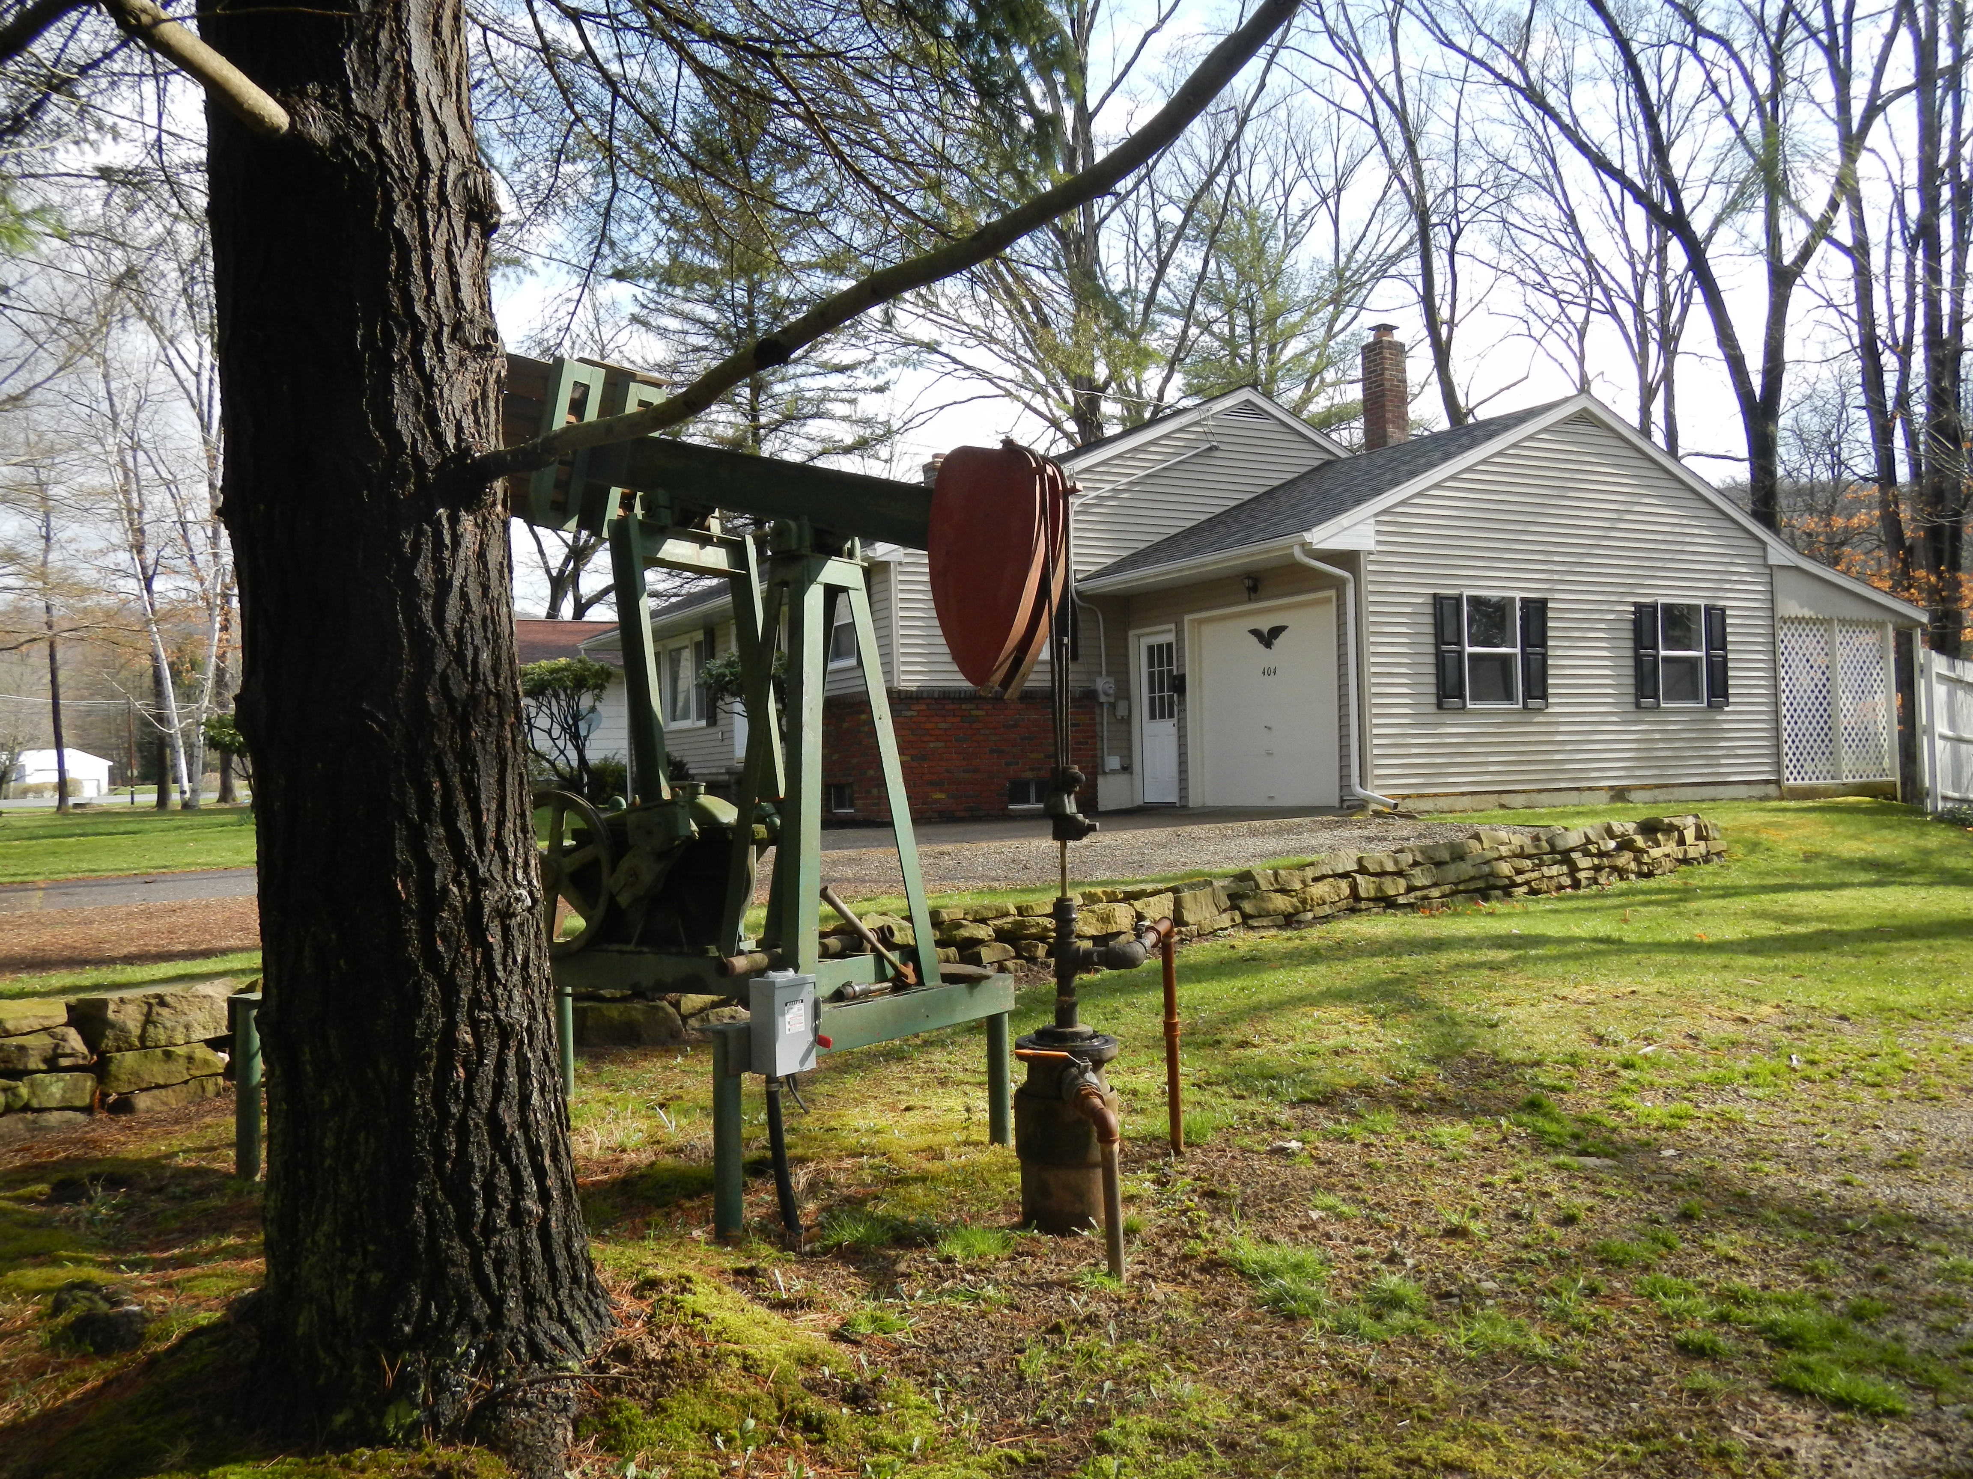
Conventional wells are small installations. When driving or recreating in western PA you may not even be aware of the conventional well heads or pump jacks (nodding donkeys) located in the adjacent fields and woods. We operate wells in school yards, beside homes and businesses. Often the wells were there first and the buildings were constructed later. Some conventional wells are over 100 years old.
Our conventional industry employs over 5000 people and is crucial to the economies of the rural western counties where we operate.
The unconventional industry is a relative newcomer to the state, with unconventional operations getting significantly underway in the Marcellus in about 2005. PA’s unconventional industry has enjoyed spectacular growth. Today it produces massive amounts of gas from both the Marcellus and Utica formations, making PA the second largest producing state in the nation (second only to Texas).
The Marcellus and Utica formations are found deep underground. The gas in those formations is released by a combination of horizontal drilling and high volume-high pressure hydrofracturing. In contrast, PA’s conventional wells are low pressure vertical wells.
The enormous amount of gas produced from PA’s unconventional wells must go somewhere to be used. The unconventional gas comes out at such high pressures and volumes that it would overwhelm our small conventional gas distribution systems. Therefore, PA’s unconventional gas is shipped around the nation by new pipelines, some recently completed, and many still under construction.
The economics of conventional and unconventional wells are very different. Every unconventional well requires millions of dollars to drill and complete. The unconventional industry is composed almost exclusively of multinational corporations—what we would term large businesses. In contrast, new conventional wells are drilled with locally owned equipment at a cost of about $100,000. Unfortunately, conventional drilling has come to a near halt due to the flooding of the gas market with gas from unconventional wells. After the unconventional industry arrived in PA, the number of new conventional wells drilled per year has dropped by 95%.
PA’s Department of Environmental Protection (DEP) describes some of the differences between conventional and unconventional wells. According to DEP’s Act 13 Frequently Asked Questions:
A conventional gas well, also known as a traditional well, is a well that produces oil or gas from a conventional formation. Conventional formations are variable in age, occurring both above and below the Elk Sandstone. While a limited number of such gas wells are capable of producing sufficient quantities of gas without stimulation by hydraulic fracturing, most conventional wells require this stimulation technique due to the reservoir characteristics in Pennsylvania. Stimulation of conventional wells, however, generally does not require the volume of fluids typically required for unconventional wells. http://files.dep.state.pa.us/OilGas/OilGasLandingPageFiles/Act13/Act_13_FAQ.pdf
The DEP’s description focuses on one important distinction – the volume of fluids required for well completion. But there are others:
- A typical well location for a conventional well is 35 or more times smaller than that of a typical unconventional well. The conventional well pad is surfaced with a small amount of stone, often obtained on-site, as opposed to thousands of tons of surface materials applied at an unconventional location. Thus, the amount of site disturbance occurring at a conventional well site is significantly different, likened perhaps to the difference between the construction of a house and a shopping mall.

- The site needs at a conventional well are flexible (the one or two necessary water tanks can frequently be arranged on the access road rather than the location, etc.); thus, the conventional site can be more flexibly adapted to existing site terrain. This flexibility significantly reduces site disturbance and thus erosion and sedimentation.

- A conventional drilling and completion operation involves a dozen or less heavy truck trips in and out as opposed to hundreds, or sometimes thousands, for unconventional wells, thus significantly reducing road requirements, sedimentation from road travel, and stress on local municipal roadways.

- The drilling and completion of a conventional well requires just a few diesel engines as compared with dozens or even hundreds at unconventional well. At a conventional site, engines typically run for only a few hours as compared to an unconventional site where engines run for days. Thus, the air quality impact at a conventional site is minimal.

- The scope of conventional well stimulation extends a few hundred feet into the oil and gas bearing strata rather than the several thousand feet involved in unconventional well stimulation. This different scope accounts for the qualitatively different equipment and water requirements.

- Wellhead pressures of new conventional wells are only several hundred pounds and quickly reduce to very low pressures. Most conventional wells in Pennsylvania operate at less than 50 psi. Wellhead pressures of new unconventional wells are measured in thousands of pounds.

- A conventional oil or gas well has a much smaller footprint in the production phase itself. Once construction is completed, conventional well sites are almost entirely restored, leaving only a single wellhead, pumpjack and other necessary equipment, and enough space to service and maintain the well.

